%Exercise 1

function LAB05ex1

m = 1;

k = 4;

omega0=sqrt(k/m);

y0=0.1; v0=0;

[t,Y]=ode45(@f,[0,10],[y0,v0],[],omega0);

y=Y(:,1); v=Y(:,2);

figure(1); plot(t,y,'b+-',t,v,'ro-');

gridon;

%------------------------------------------------------

functiondYdt= f(t,Y,omega0)

y = Y(1); v= Y(2);

dYdt = [v; -omega0^2\*y];

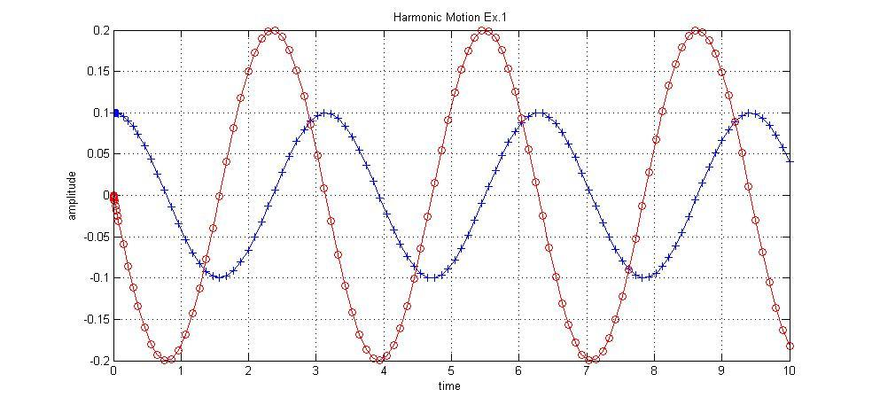% This plot displays amplitude vs. time for an undamping spring. No energy is lost in the system therefore the max and min of the amplitude maintain constant.

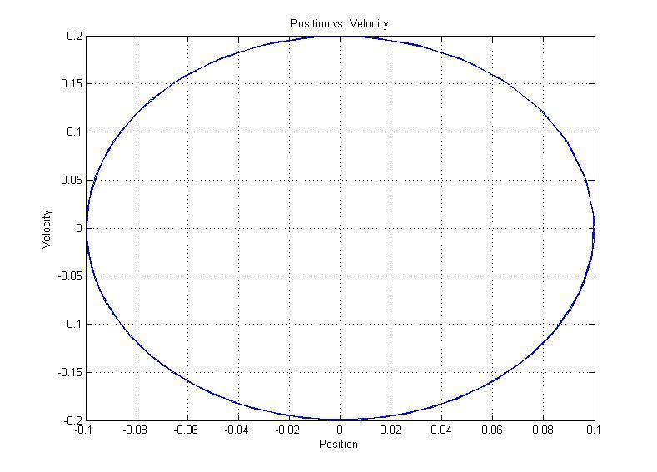

% This plot displays velocity vs. position for an undamping spring. The curve does not plot the origin because energy is not being lost over time.

% part(a) The blue curve represents y=y(t) because y(0)=0.1 and the initial condition for y is 0.1.

% part(b) The period is pi.

$T=\frac{2π}{w_{o}}=\frac{2π}{2}=π$

% part(c) The mass will never come to rest because there is no damping in the system. The amplitudes therefore remain constant.

% part(d) It can be observed that the amplitude of oscillation is0.1.

% part(e) The maximum speed attained equals the amplitude of the red curve which is 0.2 at t values $π/4$, $3π/4$, etc.

% part(f) When k is fixed and m increases, the T value increases. When the m is fixed, and k is increased, the T value decreases.

$$T=\frac{2π}{w_{o}}=2π\sqrt{\frac{m}{k}}$$

%Exercise 2

function LAB05ex1

m = 1;

k = 4;

c = 1;

omega0 = sqrt(k/m); p = c/(2\*m);

y0 = 0.1; v0 = 0;

[t,Y]=ode45(@f,[0,10],[y0,v0],[],omega0,p);

y=Y(:,1); v=Y(:,2);

figure(1); plot(t,y,'b+-',t,v,'ro-');

gridon

E=(1/2)\*m\*v.^2+(1/2)\*k\*y.^2;

figure(2)

plot(t,E)

ylim([0,0.04])

%------------------------------------------------------

functiondYdt= f(t,Y,omega0,p)

y = Y(1); v= Y(2);

dYdt= [v; -omega0^2\*y ];

% part(a) When the limits on y are changed, a straight line occurs.

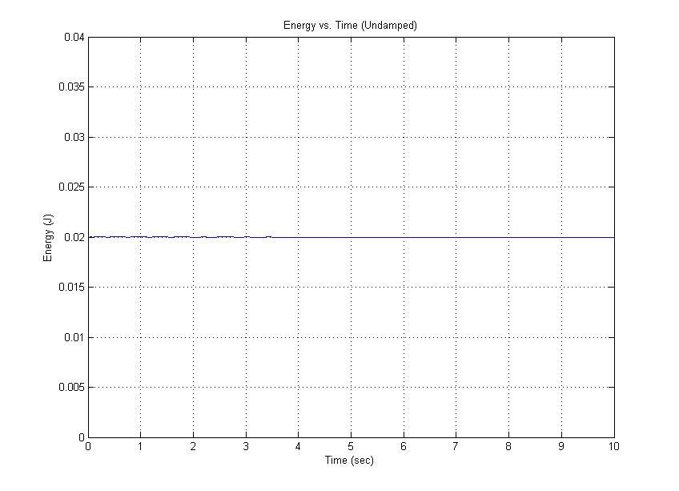

% The above plot shows energy vs. time for an undamped spring. The slope of the line is zero, meaning that there is no change in energy over time. It remains at the value of 0.02.

% part(b) Analytically, energy should be conserved.

$$E=\frac{1}{2}mv^{2}+\frac{1}{2}ky^{2}$$

$$\frac{∂E}{∂t}=mvv^{'}+kyy^{'}$$

$$From ODE: v=y^{'}v^{'}=y"=-w_{o}^{2y}$$

$$\frac{∂E}{∂t}=my^{'}\left(-w_{o}^{2y}\right)+kyy'$$

$$=my^{'}\left(-\frac{k}{m}y\right)+kyy'$$

$$=-kyy^{'}+kyy^{'}=0$$

% part(c)The plot is an ellipse; since the plot never goes through or even approaches the origin, it can be deduced that the mass never comes to rest. Velocity and position are never simultaneously 0.

%Exercise 3

function LAB05ex1

m = 1;

k = 4;

c = 1;

omega0 = sqrt(k/m); p = c/(2\*m);

y0 = 0.1; v0 = 0;

[t,Y]=ode45(@f,[0,10],[y0,v0],[],omega0,p);

y=Y(:,1); v=Y(:,2);

figure(1); plot(t,y,'b+-',t,v,'ro-');

gridon

fori=1:length(y)

m(i)=max(abs(y(i:end)));

end

i = find(m<0.01); i = i(1);

disp(['|y|<0.01 for t>t1 with ' num2str(t(i-1)) '<t1<' num2str(t(i))])

vmax=max(abs(v));

i=find(v<=-vmax);

disp(['maximum velocity is v = ' num2str(vmax) 'attained at t =' num2str(t(i))])

figure(2);

plot(y,v)

gridon

xlabel('y')

ylabel('v')

%----------------------------------------------------------------------

functiondYdt= f(t,Y,omega0,p)

y = Y(1); v= Y(2);

dYdt = [v; -2\*p\*v-(omega0^2)\*y ];

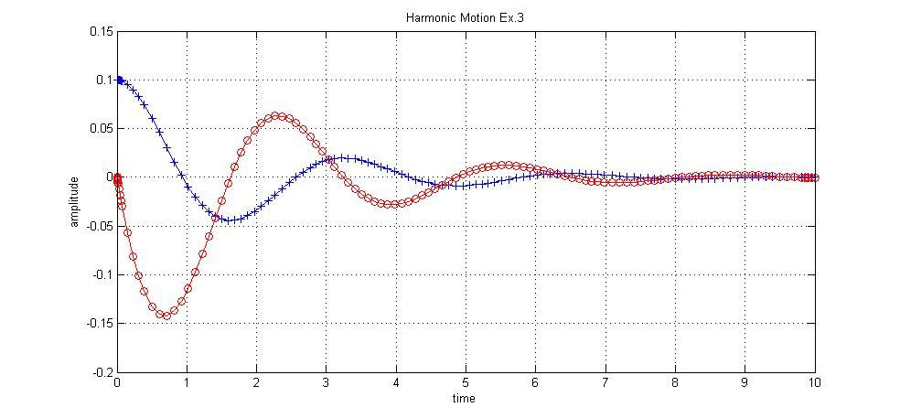

% The above plot shows the amplitude vs. time for an damping spring. The curve does not maintain a constant max and min amplitude because energy is being lost in the system.

% part(a) >>|y|<0.01 for t>t1 with 3.7807<t1<3.8711

The time t1 where the mass-spring system satisfies |y|<0.01 is from time 3.7807<t1<3.8711. This was found by adding the given part of the program to the end of the function file.

% part(b) >>maximum velocity is v = 0.14197 attained at t = 0.71477

Instead of using the magnify option and finding an approximate amplitude, a similar code that was used to find the time t1 in part (a) was used to find the maximum velocity. At time 0.71477, a maximum velocity of 0.14197 was found.

% part(c)

The larger the C value, the less the spring dampens. It is also observed that the value of c alters the time it takes the system to reach equilibrium and come to rest. The path of the position vs. velocity plot becomes less curved when c increases, thus shortening the curve length—meaning that it travels a smaller total distance before coming to rest.

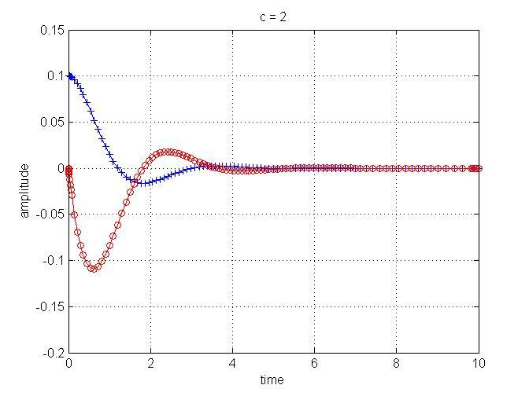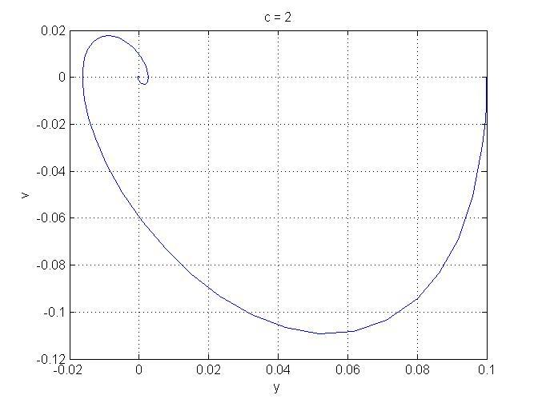

% The left plot shows the amplitude vs. time graph and the right plot shows the position vs. velocity graph when the critical value is 2.

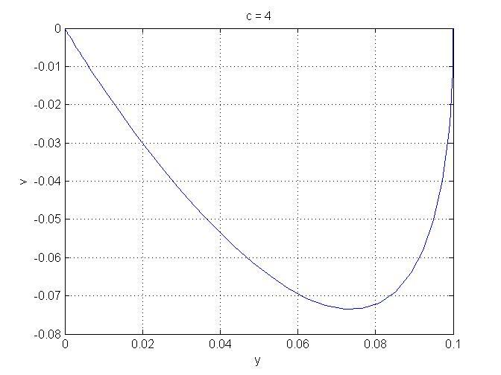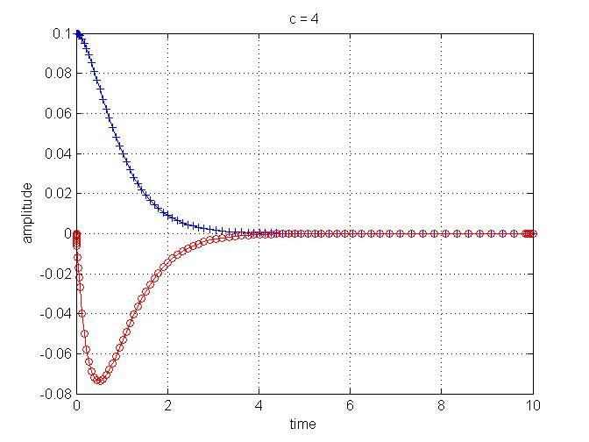

% The left plot shows the amplitude vs. time graph and the right plot shows the position vs. velocity graph when the critical value is 4.

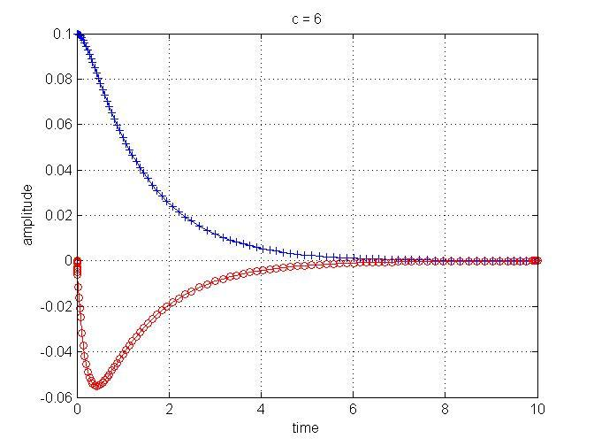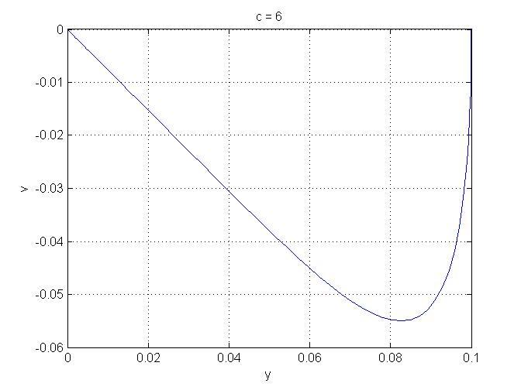

% The left plot shows the amplitude vs. time graph and the right plot shows the position vs. velocity graph when the critical value is 6.

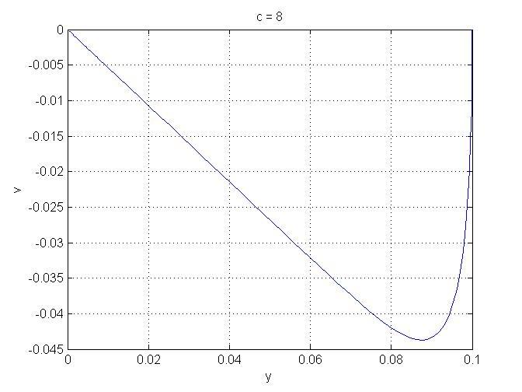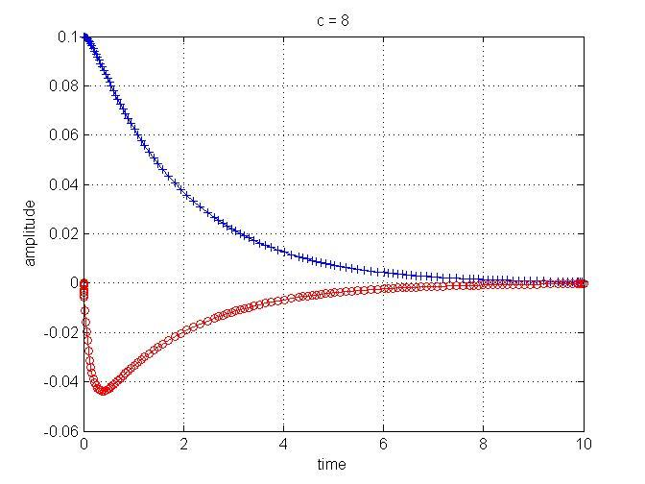

% The left plot shows the amplitude vs. time graph and the right plot shows the position vs. velocity graph when the critical value is 8.

% part(d)

There is no oscillation if and only if the characteristic equation has no complex roots.

$$mu^{''}+cu^{'}+ku=F(t)$$

$$mu^{''}+cu^{'}+ku=u$$

$$mr^{\begin{aligned}2 \\ \end{aligned}}+cr+k$$

$-c±\sqrt{c^{2}-4mk}$ (Quadratic equation)

$$*discriminant must be≥0. Smallest critical value when discriminant=0$$

$$c^{2}-4mk=0$$

$$c≥\sqrt{4mk}$$

%Exercise 4

function LAB05ex1

m = 1;

k = 4;

c = 1;

omega0 = sqrt(k/m); p = c/(2\*m);

y0 = 0.1; v0 = 0;

[t,Y]=ode45(@f,[0,10],[y0,v0],[],omega0,p);

y=Y(:,1); v=Y(:,2);

figure(1); plot(t,y,'b+-',t,v,'ro-');

gridon

figure(2)

plot(y,v)

gridon

xlabel('y')

ylabel('v')

E=(1/2)\*m\*v.^2+(1/2)\*k\*y.^2; % total energy equation

figure(3)

plot(t,E) % plot energy vs. time

%------------------------------------------------------

functiondYdt= f(t,Y,omega0,p) % function dYdt

y = Y(1); v= Y(2); % assign values of y and v

dYdt = [v; -2\*p\*v-(omega0^2)\*y ]; % fill-in dv/dt

% part(a) Energy is no longer conserved in this system. This occurs because there is now a damping constant in the system.

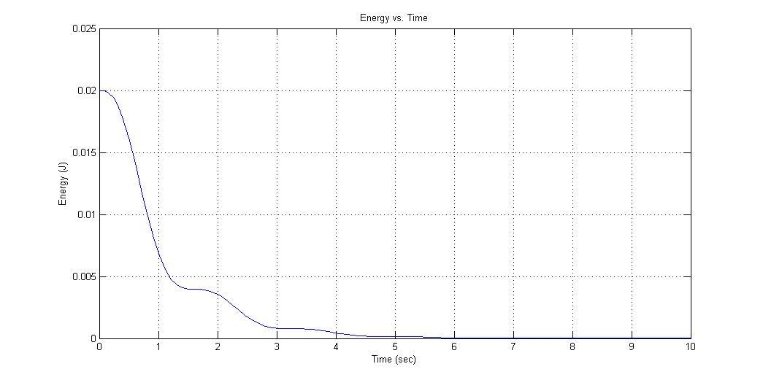

% The above graph shows energy vs. time for the damped spring. Energy approaches 0 over time.

% part(b)

$v^{'}=y^{''}=-\frac{c}{my^{'}}-\frac{k}{m}y$

$$\frac{∂E}{∂t}=my^{'}\left(-\frac{c}{my^{'}}-\frac{k}{m}y\right)+kyy'$$

$$=-c{\left(y^{'}\right)}^{2}-kyy^{'}+kyy'$$

$=-c{\left(y^{'}\right)}^{2}$ $∴ \frac{∂E}{∂t}<0 for c>0 and \frac{∂E}{∂t}>0 for c<0$

$${*\left(y^{'}\right)}^{2} is always greater than or equal to zero$$

% part(c)

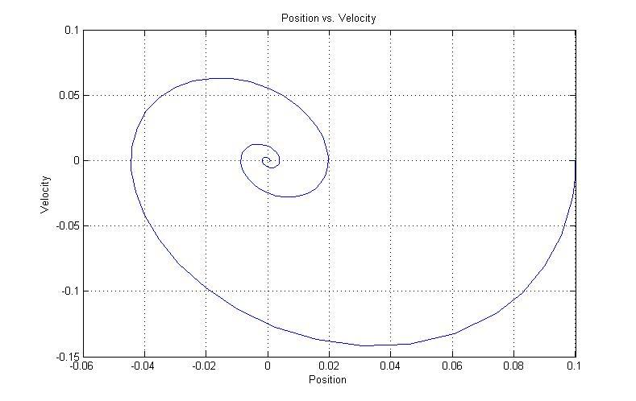The energy is not conserved in this system because there is now damping present. This causes the energy to decrease over time, which causes the system to eventually come to rest.

% The above plot shows velocity vs. position for an damping spring. The curve approaches the origin since energy is being lost with time.